Dashboard 2: (SAMI)

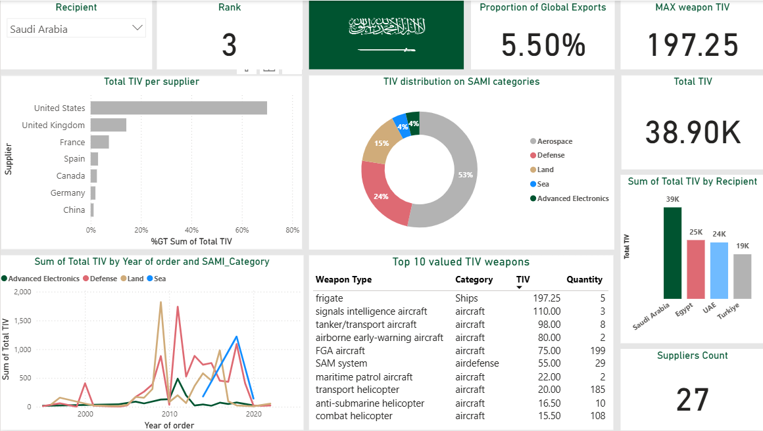

Insights:

Saudi Arabia Ranked 3 on the recipients and 5.5% on the total exports, represents that Saudi Arabia has a strong economy and spent much money to defense their valuable stuff.

Chart 1:
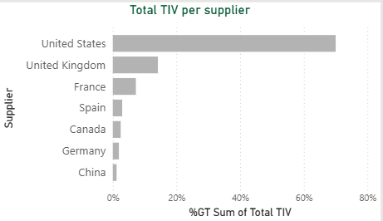
The chart shows that 70% of Saudi Arabia’s weapons come from the well-known and dependable supplier, the United States, followed by other strong partners such as the United Kingdom and France by percentage 20% and 10% to the other 24 supplier.

Chart 2:
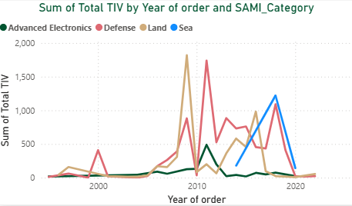
The chart shows that Saudi Arabia places orders for each SAMI category at different periods, indicating continuous research and gradual upgrades in its military systems. After 2020, the trend shifts toward local production under SAMI’s initiatives.
Chart 3:
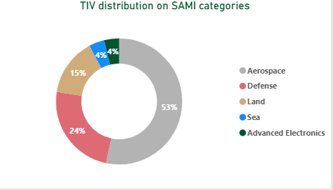
Around half of the spending goes to the aerospace sector with 53%, which aligns with military strategies that prioritize air power and air attacks.

Chart 4:
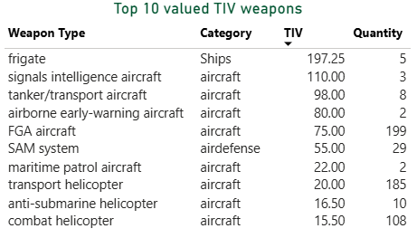
The table shows Saudi Arabia’s top 10 imported weapons. High-value systems like frigates appear in small numbers, while helicopters and aircraft are ordered in larger quantities to support readiness and flexibility

Chart 5:
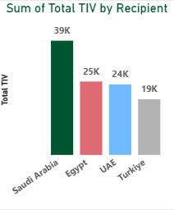
Saudi Arabia leads regional recipients with a significant difference, showing its strong defense position in the region

